Aim: To integrate Firebase Cloud Firestore in a Flutter application and perform CRUD (Create, Read, Update, Delete) operations.

Theory:

Q1. What is Navigation in Flutter? Explain how Flutter moves from one screen to another using the Navigator class.
Navigation is moving between screens in Flutter. The Navigator class manages a stack of Route objects, using push() to add new screens and pop() to return to previous ones.

Q2. Explain the navigation stack mechanism in Flutter. (Use real-life example of stack of plates)
Navigation works like a plate stack—adding (pushing) a new plate on top shows a new screen. Removing (popping) the top plate returns to the previous screen below it.

Q3. What is Routing in Flutter?
Routing defines named paths to screens in Flutter. It allows navigation using route names instead of directly creating widgets, making navigation more organized and manageable.

Q4. What is a Gesture in Flutter? Explain the use of ‘GestureDetector’ widget.
A gesture is a physical interaction like tapping or swiping. GestureDetector is a widget that detects these interactions and executes corresponding callback functions.

Q5. What are different types of gestures supported in Flutter?
Flutter supports tap, double tap, long press, drag, pan, swipe, pinch, zoom, and rotate gestures through various gesture detector callback.
Code:

Output:
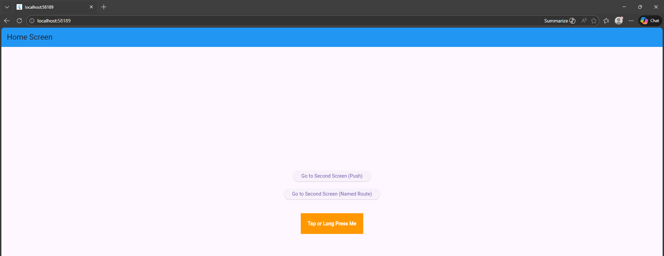
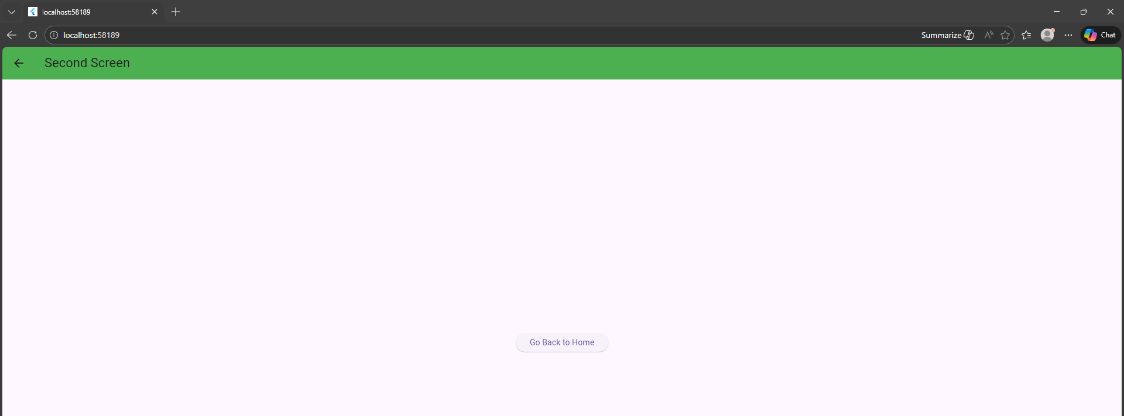
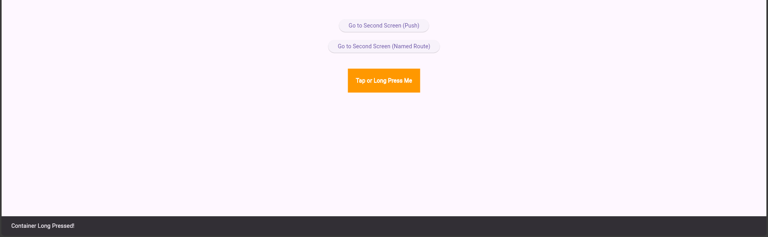

Conclusion
This experiment demonstrated navigation, named routing, and gesture handling in Flutter using Navigator methods and GestureDetector. It helped in understanding screen transitions and user interaction in a multi-screen application.

